**VISVESVARAYA TECHNOLOGICAL UNIVERSITY**

**Jnana Sangama, Belgaum-590018**



**A Database Management System Mini Project Report**

**on**

**“HOTEL MANAGEMENT SYSTEM”**

**Submitted in Partial fulfillment of the Requirements for the V Semester of the Degree of**

**Bachelor of Engineering**

**In**

**Computer Science & Engineering**

**By**

**ADITI SUDHAKAR**

**(1CR18CS007)**

**ASWINI KALYAN**

**(1CR18CS034)**

**Under the Guidance of**

**Mr. Shivraj V B**

**Asst. Professor, Dept. of CSE**



# DEPARTMENT OF COMPUTER SCIENCE AND ENGINEERING

**CMR INSTITUTE OF TECHNOLOGY**

#132, AECS LAYOUT, IT PARK ROAD, KUNDALAHALLI,

BANGALORE-560037

**CMR INSTITUTE OF TECHNOLOGY**

1. #132, AECS LAYOUT, IT PARK ROAD, KUNDALAHALLI,
2. BANGALORE-560037

# DEPARTMENT OF COMPUTER SCIENCE AND ENGINEERING

1. 

**CERTIFICATE**

This is to certify that the Database Management System Project work entitled **“Hotel Management System”** has been carried out by **Aditi Sudhakar (1CR18CS007)** and **Aswini Kalyan (1CR18CS034)** bonafide students of CMR Institute of Technology in partial fulfillment for the award of **Bachelor of Engineering** in **Computer Science and Engineering** of the Visvesvaraya Technological University, Belgaum during the year **2020-2021**. It is certified that all corrections/suggestions indicated for Internal Assessment have been incorporated in the Report deposited in the departmental library. This DBMS Project Report has been approved as it satisfies the academic requirements in respect of project work prescribed for the said degree.

**----------------------- ----------------------**

**Signature of Guide Signature of HOD**

**Mr Shivraj B V Dr. Prem Kumar Ramesh**

**Asst. Professor Professor, Head**

**Dept. of CSE, CMRIT Dept. of CSE, CMRIT**

External Viva

Name of the examiners                                                                          Signature with date

1.

2.

**Abstract**

The “Hotel Management System” is a web based application for computerised management of hotel records for the administrators of the hotel as well as for the guests to view their bookings . Here, guests have the option of viewing all their details, while the admins can use this software to manage bookings and reservations. Admins have their own login and password credentials and so do the users. Hence, this website helps the admins and guests to keep track of their booking status without having to physically travel to the hotel before their stay.

ACKNOWLEDGEMENT

The satisfaction and euphoria that accompany a successful completion of any task would be incomplete without the mention of people who made it possible, success is the epitome of hard work and perseverance, but steadfast of all is encouraging guidance.

So with gratitude I acknowledge all those whose guidance and encouragement served as beacon of light and crowned our effort with success.

I would like to thank **Dr. Sanjay Jain,** Principal, CMRIT, Bangalore for providing excellent academic environment in the college and his never-ending support for the B.E program.

I would also like to thank **Dr. Prem Kumar Ramesh**,Professor and HoD, Department of Information Science and Engineering, CMRIT, Bangalore who shared his opinions and experiences through which I received the required information crucial for the project.

I consider it a privilege and honor to express my sincere gratitude to my internal guide and Co-guide**, Mr. Shivraj V B** ,Assoc. Professor, Department of Information Science & Engineering, CMRIT, Bangalore for his valuable guidance throughout the tenure of this project work.

I would also like to thank all the faculty members who have always been very Cooperative and generous. Conclusively, I also thank all the non-teaching staff and all others who have done immense help directly or indirectly during my project

Aditi Sudhakar(1CR18CS007)

Aswini Kalyan(1CR18CS034)

**TABLE OF CONTENTS**

1. **Introduction 1-2**
2. **Software Requirements 3**
3. **Design 4-5**
4. **Implementation 6-8**
5. **Screenshot 9-13**
6. **Conclusion 14**
7. **Bibliography 15**

**CHAPTER 1:**

**INTRODUCTION**

A database management system is a system software used for creating and managing databases. The DBMS provides the users and programmers with a systematic way to create, retrieve, update and manage data.

The hotel management system can help in storing records related to the stay of the guests, the amenities accessed by them, cancelation of booking etc. It also allows the administrators to cancel or approve a booking. All these records can be maintained in a single database. Security is maintained so as to ensure that only the authorised users will have access to the system. This application removes the inconvenience of traveling to the hotel physically to make modifications in the stay and can be done at the user’s convenience. It also simplifies the booking process so that the guest does not have to waste time in the process of check in and check out.

* 1. **Objectives**
* To provide an online platform to manage all the data required by the administrators .
* To display the details of the booking and the status to the user to avoid confusion.
* To provide an easy way for both admins and users to book or cancel rooms and choose the amenities that they require.
  1. **Justification**
* It is a one stop gateway for the entire booking process: right from booking to payment.
* It retrieves data very fast when compared to manual searching of data.
* Saves a lot of time and is convenient.

**CHAPTER 2:**

**SOFTWARE REQUIREMENTS**

**2.1 System Requirements**

These consist of the software components of a computer system that are required to be installed in order to use the software efficiently.

* + 1. **Software Requirements**

1. **Operating system**: Windows 10/8/7
2. **Technology:** PHP
3. **Database:** MySQL
4. **IDE:** Atom
5. **Software:** XAMPP Server

**2.2 User Requirements**

A Web browser with the Xampp server (mainly to use the Apache web server that is provided by Xampp).

**CHAPTER 3:**

**DESIGN**

**ER-DIAGRAM**

An entity-relationship diagram (ERD) is a data modeling technique that graphically illustrates an information system’s entities and the relationships between those entities. An ERD is a conceptual and representational model of data used to represent the entity framework infrastructure.

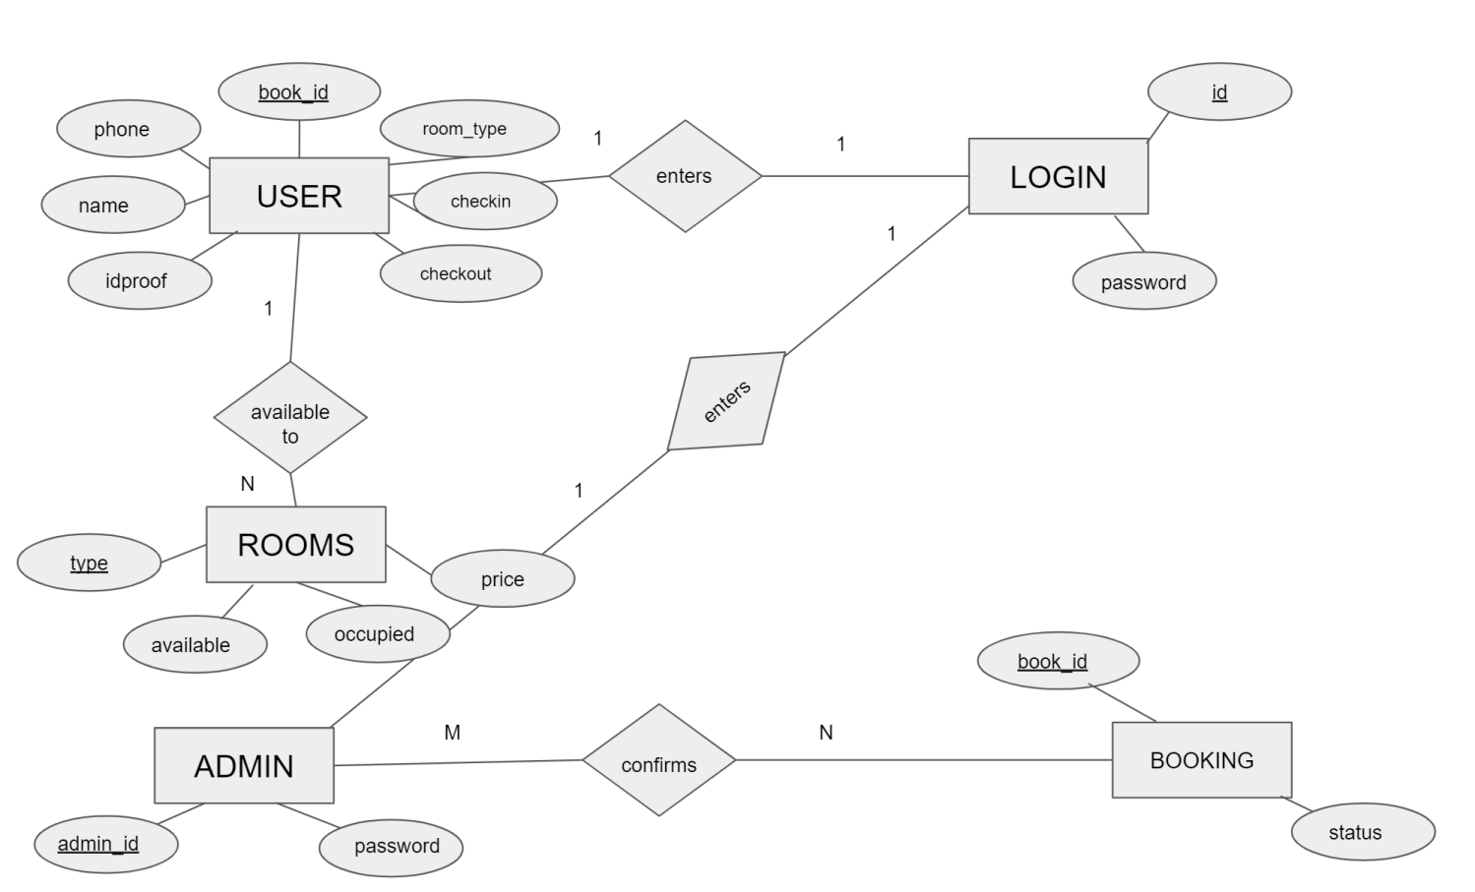

FIG 1: ER-DIAGRAM for Hotel Management System

**3.1 List of Schemas:**

A schema is a logical database object holder. A database schema of a database system is its structure described in a formal language supported by the database management system. The formal definition of a database schema is a set of formulae (sentences) called integrity constraints imposed on a database. These integrity constraints ensure compatibility between parts of the schema. All constraints are expressible in the same language.

Creating schemas can be useful when objects have circular references, that is when we need to create two tables each with a foreign key referencing the other table. Different implementations treat schemas in slightly different ways. The different schemas used are:

* USER (name, phone, room_type, book_id, idproof, checkin, checkout, price)
* ADMIN (admin_id, password)
* ROOMS (room_type, available_rooms, occupied_rooms, price)
* LOGIN (name, phone, password, id)
* BOOKING (name, phone, room_type, book_id, idproof, checkin, checkout, price, status)

**3.2 List of Primary keys:**

A primary key is a field in a table which uniquely identifies each row/record in a database table. Primary keys must contain unique values. A primary key column cannot have NULL values.

A table can have only one primary key, which may consist of single or multiple fields. When multiple fields are used as a primary key, they are called a composite key.

If a table has a primary key defined on any field(s), then it cannot have two records having the same value of that field(s). The different primary keys used are:

* book_id
* adminid
* room_type
* idproof
* book_id

**CHAPTER 4:**

**IMPLEMENTATION**

**4.1 List of models**

**ADMIN MODEL:**

The main objective of this model is to provide all the admins with access to the booking table. It provides options for the admins to approve, cancel or modify the stay of the guest. Features of the admin model are:

* Admins can authenticate the bookings with their user credentials.
* Admins can approve, cancel or modify the stay of the guest.

**USER MODEL:**

The main aim of this model is to provide a view only information for the users. So all the guests will be able to view some details, but can modify some. Features of the user model are:

* Users can book a room or cancel their booking.
* Users can view their booking status.

**4.2 TRIGGER**

 Triggers are stored programs, which are automatically executed or fired when some events occur. Triggers are, in fact, written to be executed in response to any of the following events

* A **database manipulation (DML)** statement (DELETE, INSERT, or UPDATE)
* A **database definition (DDL)** statement (CREATE, ALTER, or DROP).
* A **database operation** (SERVERERROR, LOGON, LOGOFF, STARTUP, or SHUTDOWN).

Triggers can be defined on the table, view, schema, or database with which the event is associated.

### **Benefits of Triggers**

Triggers can be written for the following purposes −

* Generating some derived column values automatically
* Enforcing referential integrity
* Event logging and storing information on table access
* Auditing
* Synchronous replication of tables
* Imposing security authorizations
* Preventing invalid transactions

**TRIGGER CODE:**

On Insertion of new user credentials:

INSERT into user_login values(null,NEW.email,NEW.password,NOW(),"inserted")

On Updation of checkout date

INSERT into confirmed_booking values(null,NEW.checkout,NEW.price,NOW(),"updated")

On cancellation of room booking

INSERT into booked_list values(null,OLD.book_id,OLD.status,NOW(),"deleted")

**4.3 STORED PROCEDURE**

The My SQL Server **Stored procedure** is used to save time to write code again and again by storing the same in the database and also get the required output by passing parameters.

The following is the Syntax for the Stored procedure:

DELIMITER //

CREATE PROCEDURE user_login

BEGIN

SELECT Phone FROM user_login;

END //

DELIMITER ;

**CHAPTER 5:**

**SCREENSHOTS**

The following snapshots and define the results or outputs that we got after step by step execution of each proposed protocol for different values.

**LOGIN PAGE :**

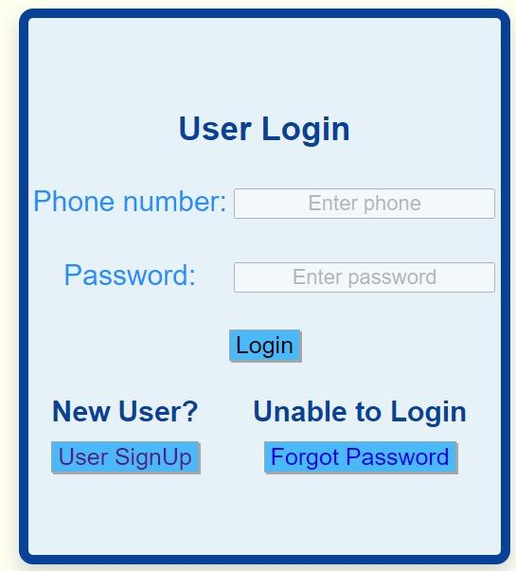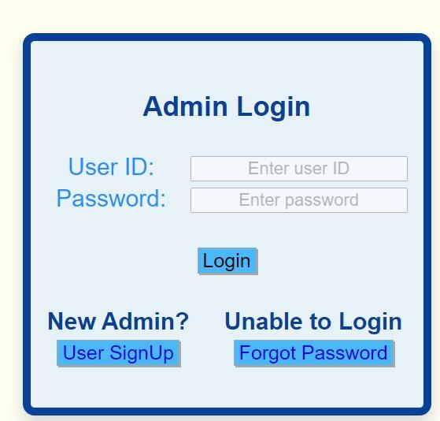

FIG 2 : Login Pages for Users and Admins

**REGISTRATION PAGE:**

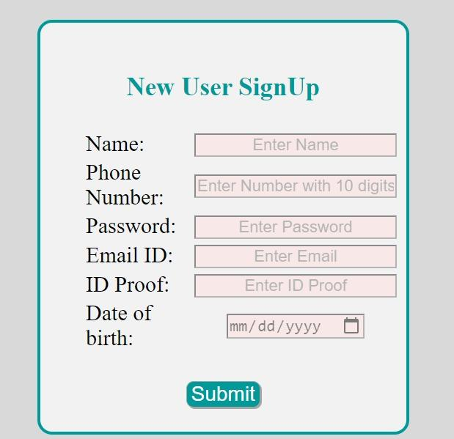

FIG 3: New User Registration for User in Hotel Website

**HOME PAGE:**

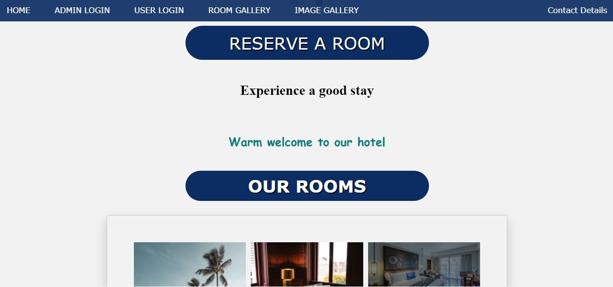

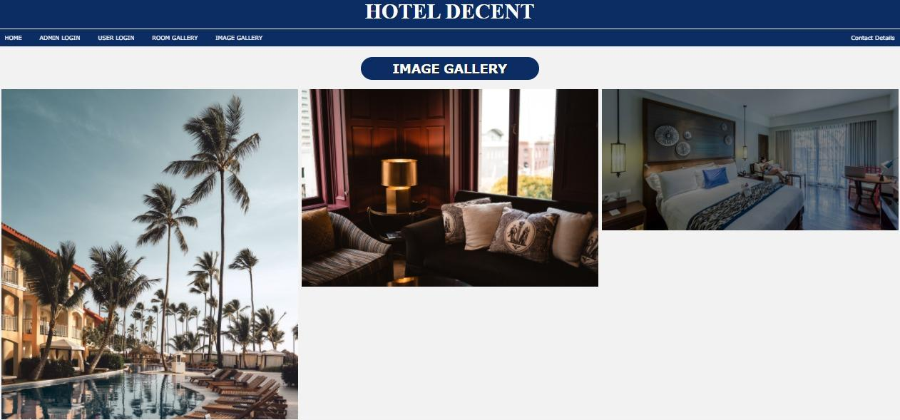

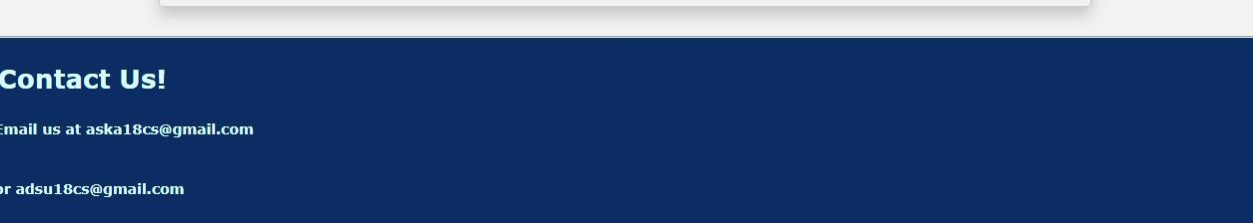FIG 4: Home Page for Hotel Website

**USER INTERFACE**

**ROOM BOOKING:**

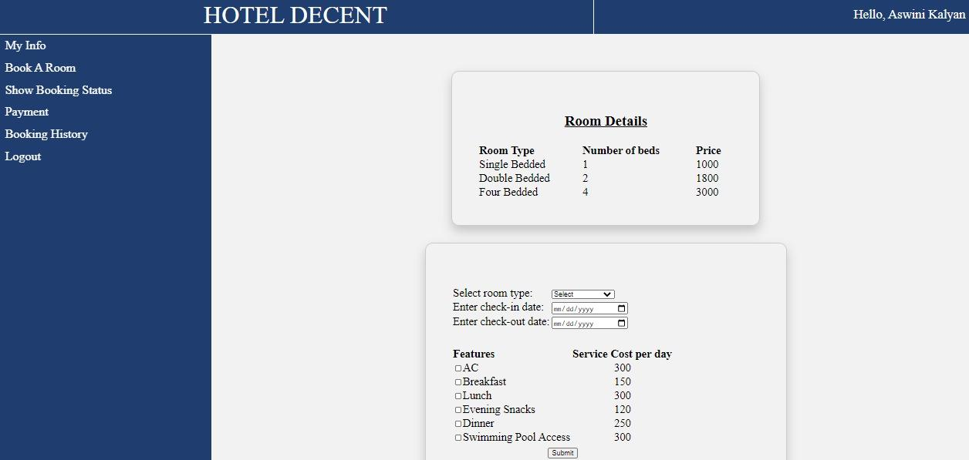

FIG 5: Page for Booking a Room in Hotel Website

**BOOKING STATUS:**

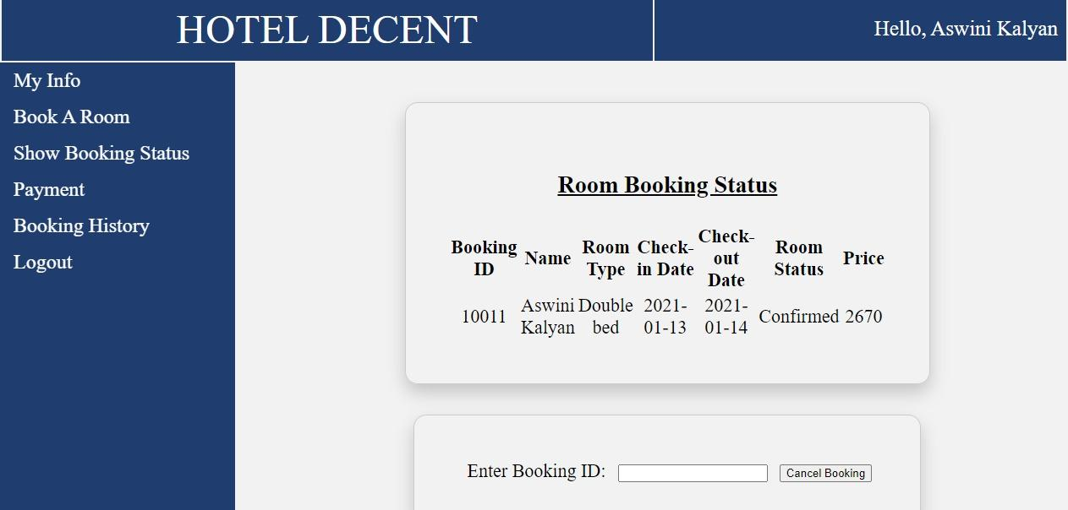

FIG 6: Room Booking Status Visible to Guest in Hotel Website

**BOOKING HISTORY: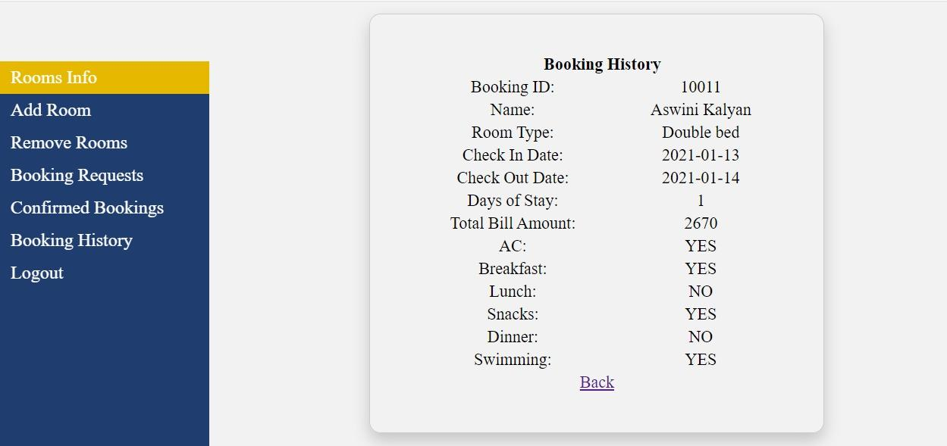**FIG 7: Booking History of Guest in Hotel Website

**ADMIN INTERFACE**

**CONFIRMING BOOKINGS:**

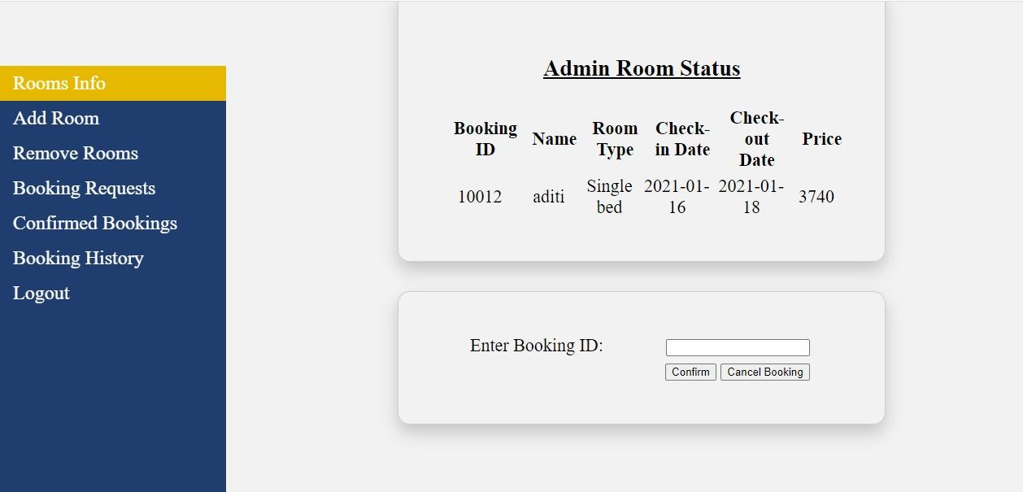

FIG 8: Confirmation of Booking by Admin in Hotel Website

**MODIFYING STAY OF GUEST:**

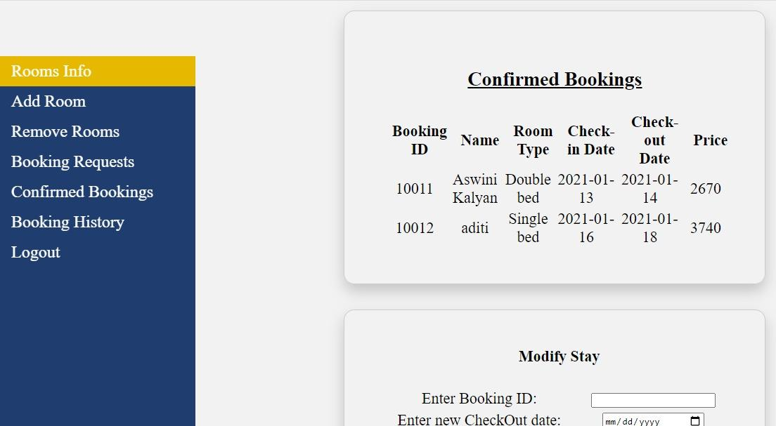

FIG 9: Modification of Guest’s Stay by Admin in Hotel Website

**CHAPTER 6:**

**CONCLUSION**

Computerised records are easier to manage and update. Manual work is time taking and error prone. This application was designed to manage an entire hotel database in a very efficient manner with a user friendly Graphical User Interface(GUI). Thus, the Hotel Management System overcomes some of the limitations of the existing system along with being a very user friendly application.

**CHAPTER 7:**

**BIBLIOGRAPHY**

* [**https://www.youtube.com/watch?v=X0_pthMQPMM**](https://www.youtube.com/watch?v=X0_pthMQPMM)
* [**https://www.cloudways.com/blog/connect-mysql-with-php/**](https://www.cloudways.com/blog/connect-mysql-with-php/)
* [**https://www.youtube.com/watch?v=zpTlJ6dtOxA**](https://www.youtube.com/watch?v=zpTlJ6dtOxA)
* [**https://www.w3schools.com/php/**](https://www.w3schools.com/php/)